**CDD CHANGING SST TUBES**

In December 2016, CDD began sending out the new SST tubes to the military sites. The new SST tubes were BD Vacutainer and would replace the Greiner SST tubes. POC’s were informed to

rotate their stock of HIV tubes so that any unexpired Greiner Vacuette tubes (tubes with a red/yellow top) were used before using the new BD vacutainer tubes.

On February 21 2017 CDD sent out an email to the all sites informing them that CDD was reverting back to using the Greiner tubes. Again the sites were requested to rotate their tube stock so as to use them in order of expiration dates. One of the major reasons for reverting back to the Greiner tubes is that the BD Vacutainer tubes did NOT have the “minimum and maximum fill line” markings on the tube labels. In your site’s next tube supply order you will receive the Greiner tubes. Please make sure that your site rotates your stock of tubes by expiration date and not by the brand of tube.

**SAMPLE HANDLING OF GREINER AND BD TUBES**

The handling of the specimens will vary slightly depending on which tube you are using. The centrifugation of the specimens is different per manufacturer instructions. Please see the attachment for the specific handling of the Greiner and BD tubes.



**Greiner Tube (Red top with yellow inside ring)**

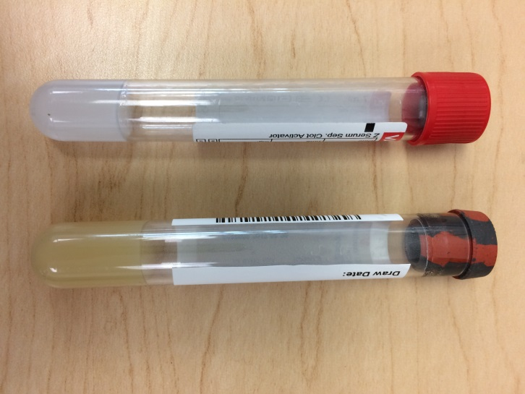

**BD Vacutainer Tube (Brick red color top)**

**NBIMC 2017 SCHEDULED COMPUTER DOWNTIMES**

The following are the monthly computer downtimes for NBIMC. There will be scheduled network maintenance done to our systems on those dates**. All the listed dates are Sundays-(all are the 3rd week in the month). All scheduled downtimes are from 0700 (EST) to 1500(EST).**

|  |  |
| --- | --- |
| **MONTH** | **DATE** |
| April | 16 |
| May | 21 |
| June | 18 |
| July | 16 |
| August | 20 |
| September | 17 |
| October | 15 |
| November | 19 |
| December | 17 |

Please mark your calendars with these dates.

**DATA MISMATCH REJECTIONS**

A D-5 rejection code is when the specimen is rejected due to a “data mismatch error”. Each HIV specimen shipped to CDD must have a minimum of 2 identifiers of PII (Personal Identifiable Information) on the tube. PII can be first name, last name, complete SSN#, date of birth etc. More than 2 identifiers can be used, but ALL identifying PII information on the label must be correct or it will be rejected as a “data mismatch”. Please make sure to double check the PII on the tube against what is being entered in the computer system electronically to make sure they match to eliminate receiving a D5 rejection error. Please print any PII legibly on the labels so that the specimen isn’t rejected for “UNREADABLE PII”. Do not use gel pens to write the PII as gel pens smear and the PII becomes unreadable.